Please tick appropriate project:

ENG5059P (MSc) | √

Student Name | Youqi Cheng
Student GUID Number | 2698734C
Degree programme | Computer System Engineering
Working Title of Project | Longitudinal microbiome analysis of healthy chicken ceca
Name of Supervisor(s) | Umer ljaz
Academic year | 2021-2022

Introduction
Chickens are one of the most important food resources for humans. Chicken meat is rich in nutrients, with good concentrations of all the essential vitamins (mainly vitamin B). Chickens are most commonly raised and slaughtered than all other poultry species. It is estimated that more than 50 billion chickens are raised for meat and eggs in the world each year (reference?).

Chickens carry many pathogenic microbes including Campylobacter, causing bacterial foodborne gastroenteritis, and in later stages Guillain-Barre syndrome, growth retardation in children especially in low-resource countries. Despite an evident Campylobacter impact and economic burden, it is unclear that how and when it appears in chickens. The lack of replicated daily microbiome data, associated metadata, and lack of natural infection studies collectively deferred our understanding about the Campylobacter colonization in chicken gut.

So it is important to study the relationship between the changes of Campylobacter in the chicken gut and the environment. This study performed a microbiome analysis of 16S rRNA samples collected from days 3 to 35 of the chicken cecum, in a natural environment known to be extra prevalent in Campylobacter. Our focus is on understanding how the cecum microbiota develops, and the potential ecological phenomena that make up the microbial community. ”

Aims/Objectives of project
Analyzing the sample data of chicken gut microbial communities during experimental period from day 3 to day 35.
Exploring the development of cecum microbiome and factors affecting microbial community asembly. Understanding the underlying ecological phenomena that structure the chicken gut microbial communities.
Determining the colonization time of Campylobacter and its relatedness with other species or mechanisms.

Resources required
- Dataset (Sequence data and Meta-data)
- R and R studio
- Paper references
- Suitable algorithms

GANTT chart

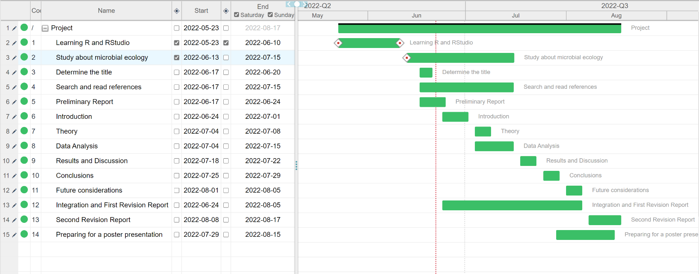

Risk assessment
1.
Risk: Unavailability of data
Likelihood without control measures: Improbable
Severity: Slight
Control measures to mitigate risk: The data for the project is provided by the supervisor, and is available on a shared repository as well as a backed up
Likelihood with control measures: Improbable

2.
Risk: Data corruption
Likelihood without control measures: Unlikely
Severity: Moderate
Control measures to mitigate risk: The project data is provided on a Dropbox repository (which maintains history for 30 days), as well as saved as a local copy on personnel computer, and in the event of data corruption, the extra copies will be used
Likelihood with control measures: Unlikely

Risk: Mental fatigue
Likelihood without control measures: Likely
Severity: Moderate
Control measures to mitigate risk: The project involves support of additional volunteers (who are PhD students/PDRAs associated with the supervisor's lab), as well as benefits from working in a team environment, with specific and measurable weekly milestones, ensuring the work is balanced in the duration of the project. The training and support is provided by the supervisory team, and access to statistical tools (existing programming codes from numerous projects) ensures reduced anxiety and concerns.
Likelihood with control measures: Likely

